
MT 1008
FINAL PROJECT
“Temperature Variation Modeling in a Room Using Partial Derivatives”

MUBEEN KHALID
24I-0605
ASHAR AHMAD
24I-0621

- Introduction
Enclosed room with two dimensions, containing subtle mechanisms of temperature variation and flow is explored in this report, with the help of multivariable calculus principles, for modelling and analysis. It is basic to many fields of practice – architectural design, building climate control, and industrial applications where temperature control is critical to efficiency – how temperature effects behave in confined spaces. The subject field of this study is based upon the application of partial derivatives for computing values of temperature gradients which are essential in the determination of the direction and rate of heat flow in the room. From these gradients, the researchers can determine areas of heat build ups and their impacts giving insightful information about the thermal response of the environment. A regular, continuously differentiable function is used to mathematically model the variation of temperature, the portrayal of the spread of heat from a localised origin.
To emulate real world environment, a reliable heat source is accurately stationed in the room to generate heat flow opportunities as a result of temperature differences. The configuration of this experiment enables the study of the way temperature distributes itself over time to show patterns affected by the position of the heat source, geometry of room, and thermal properties of adjacent materials. As a result of the application of numerical approaches and computational tools, the researchers can visualize the spatial distribution of temperature and the dynamics of heat flow that follow. Theoretical exploration, as this study offers, goes beyond implications as the understanding obtained bears practical application in multiple fields. For instance, research into heat flow within two-dimensional systems can be applied to plans for energy efficient buildings, while research can add to environmental science by explaining how heat reacts in different surfaces and matters, influencing the local climates and ecosystems. The approach used for the modelling process in this report will be explained including a mathematical framework used to deduce temperature gradients and computational procedures used in simulating heat flow.

2.) Coverage of This Topic
2.1) Temperature Function Modelling: A two dimensional temperature function located at the centre of a heat source.
2.2) Partial Derivative Calculation: Employing ∂T/∂x and ∂T/∂y for temperature change analysis.
2.3) Gradient Visualization: Demonstrating heating flow via quiver plots.
2.4) Interpretation: Physically interpretable description of the way in which heat diffuses through space.
This project integrates multivariable calculus and computational techniques to provide a visual and analytically deep exploration of temperature variation in space.

3.) Main Objectives of the Project
3.1) Model a 2D Heat Source
- Apply multivariable functions in order to describe the heat distribution in a two-dimensional space.
- To enable proper model then define the heat source characteristics and boundary conditions.
3.2) Analyse Heat Flow
- Employ partial derivatives (∂T/∂x, ∂T/∂y) to determine the rate of temperature change in both the x and y directions.
- Investigate how variations in temperature affect heat flow and distribution across the modelled area.
3.3) Visualize Temperature Gradients
- Design heat maps to visualize temperature variations which will be easy to interpret data.
- Generate vector fields as illustrations of the direction and amount of heat flow to advance thermal dynamics understanding.
3.4) Demonstrate Practical Applications
- Emphasise the importance of multivariable calculus in finding true thermal puzzles of human life (i.e. in engineering and the environmental scientific area).
- Use case studies or examples in which such mathematical ideas are used to the optimization of thermal management in different systems.

4.) Methodologies
  - Define Temperature Function: A Gaussian heat distribution model is established to represent the temperature field.
The Gaussian heat distribution centered in the room is defined as:
T(x, y) = A * e^(-α((x - x₀)² + (y - y₀)²))
Where:
A is the peak temperature,
α controls the spread,
(x₀, y₀) is the source location.

  - Compute Partial Derivatives: Partial derivatives are calculated to determine temperature. The partial derivatives are computed as:
∂T/∂x = -2α(x - x₀)T(x, y)
∂T/∂y = -2α(y - y₀)T(x, y)
are gradients, which indicate the direction and rate of temperature change.
  - Evaluate on Grid: A mesh grid is created for numerical evaluation of the temperature and its gradients across the spatial domain.

  - Visualize: Heat maps and quiver plots are generated to visually represent the temperature distribution and heat flow patterns.

  - Analyze Results: The visualizations are interpreted to identify patterns, trends, and insights from the simulation.
5.) Flow Chart
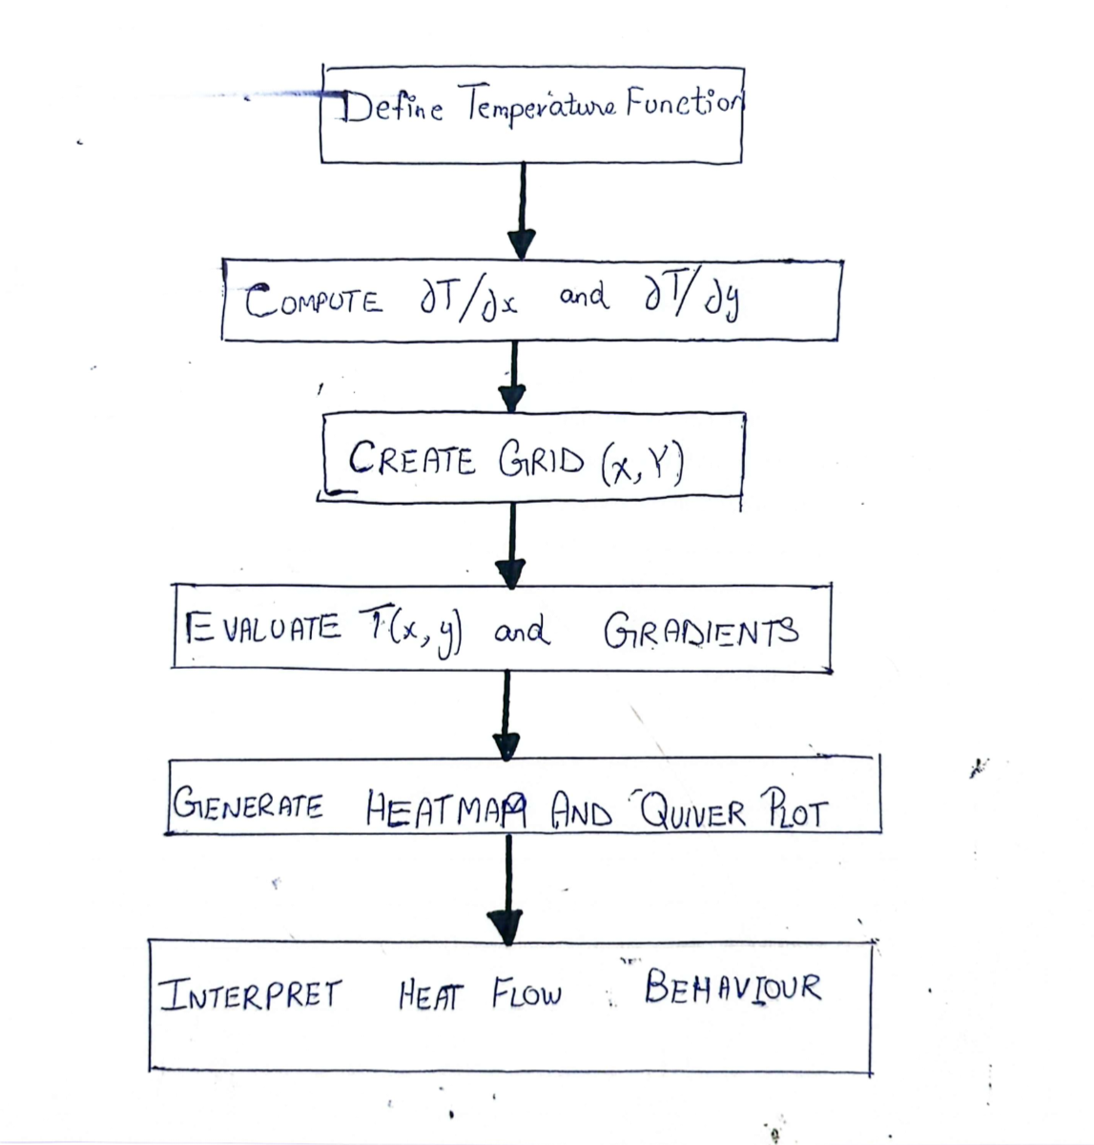

6.) Implementation
  - Model Setup
Room Dimensions: 10 × 10 units.
Heat Source at center: (5, 5)
Function:
T(x, y) = 100 * e^(-0.1((x - 5)² + (y - 5)²))

  - Heat Map:
A smooth 2D Gaussian plot visualizes how temperature drops with distance from the center.

  - Gradient Field (Quiver Plot):
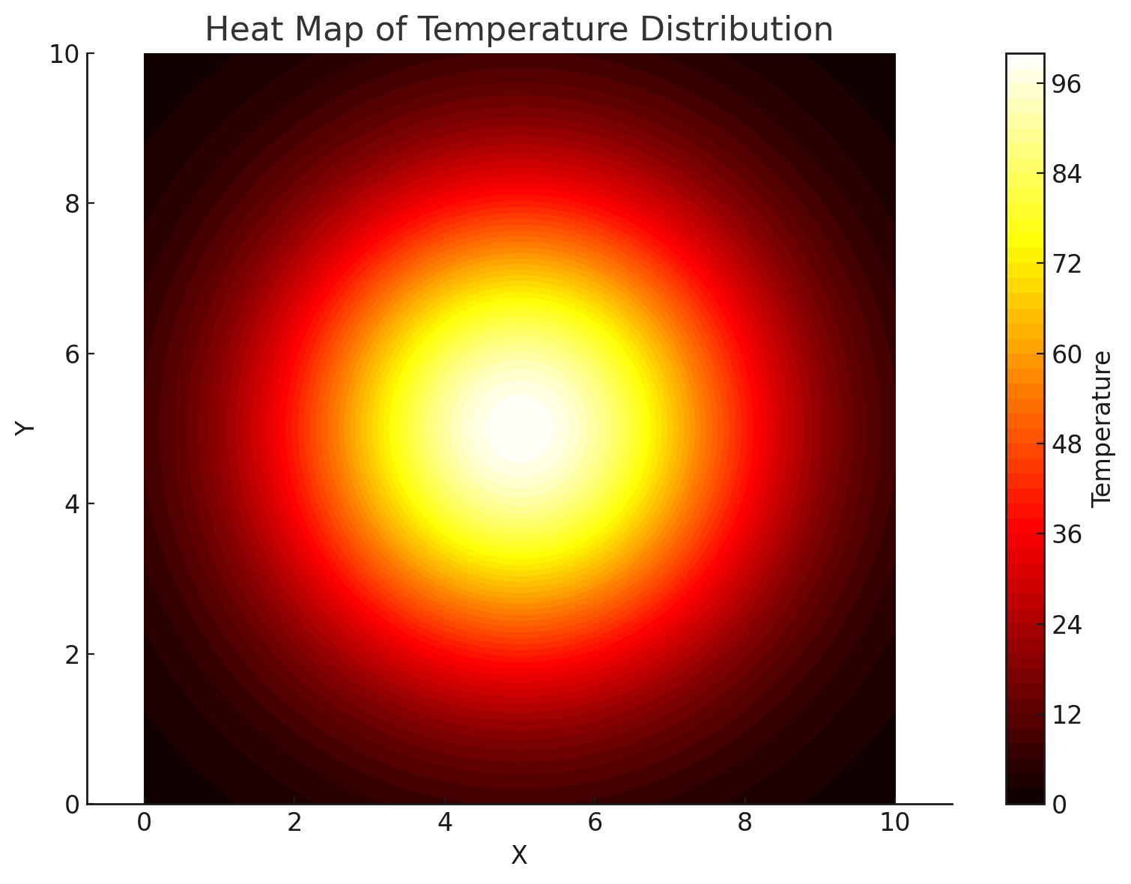
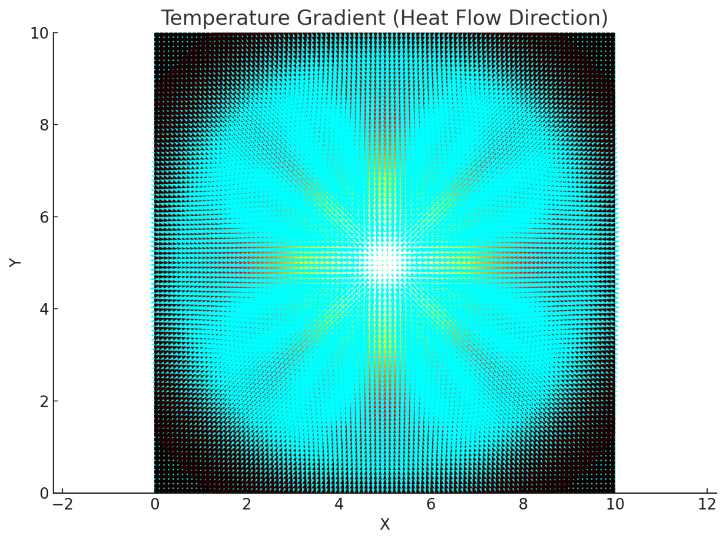

7.) Gradient Interpretation
The gradient vector:
∇T = (∂T/∂x, ∂T/∂y)
“Points in the direction of steepest increase of temperature, so heat flows against this direction (from hot to cold).”

7.1) Magnitude of Heat Flow
Gradient magnitude |∇T| reflects how quickly temperature changes. Stronger near the source, weaker far away.

8.) Analysis of Heat Flow Behavior
8.1) Symmetry: In virtue of the Gaussian shape the heat is distributed symmetrically about the center.

8.2) Directional Behavior: Vectors are radially outward in behavior — temperature falls off as we go away from source.

8.3) Realism: The obtained mathematical model closely resembles the heat diffusion in real environments (e.g. central heating systems).
9.) Conclusion
For this reason, this project has illustrated the central role of multivariable calculus, particularly use of partial derivatives, in tackling modeling and understanding of physical phenomenon as seen in distribution of heat. We plotted and analyzed the temperature behavior in a room heated from the center using simulations and gradient analysis. This argues in favor of that calculus is not merely a mathematical instrument but is also a connection of theory and practical applications.

10.) Practical Applications
This technique is foundational in:

- Thermal Engineering (heater location optimization e.g.).

- Architecture (e.g., insulation planning).

- Environmental Modeling (such as wild fire or pollutant spreading).

- Game Development (ex: sensible simulation of environemtns).

11.) Annexure
- Python Code for Simulation:
import numpy as np
import matplotlib.pyplot as plt

# --- Parameters ---
A = 100 # Maximum temperature
alpha = 0.1 # Spread factor
x0, y0 = 5, 5 # Heat source location

# --- Grid setup ---
x = np.linspace(0, 10, 100)
y = np.linspace(0, 10, 100)
X, Y = np.meshgrid(x, y)

# --- Temperature function ---
T = A * np.exp(-alpha * ((X - x0)**2 + (Y - y0)**2))

# --- Partial derivatives ---
dTdx = -2 * alpha * (X - x0) * T
dTdy = -2 * alpha * (Y - y0) * T

# --- Plot Heatmap ---
plt.figure(figsize=(8, 6))
heatmap = plt.contourf(X, Y, T, 50, cmap='hot')
plt.colorbar(heatmap, label='Temperature')
plt.title('Heat Map of Temperature Distribution')
plt.xlabel('X')
plt.ylabel('Y')
plt.axis('equal')
plt.grid(False)
plt.tight_layout()
plt.savefig('Heatmap.png') # Save image
plt.show()
# --- Plot Gradient Field (Quiver Plot) ---
plt.figure(figsize=(8, 6))
plt.contourf(X, Y, T, 50, cmap='hot') # Background heatmap
plt.quiver(X, Y, -dTdx, -dTdy, color='cyan', scale=1000, width=0.0025)
plt.title('Temperature Gradient (Heat Flow Direction)')
plt.xlabel('X')
plt.ylabel('Y')
plt.axis('equal')
plt.grid(False)
plt.tight_layout()
plt.savefig('QuiverPlot.png') # Save image
plt.show()
- Heatmap and Gradient Figures
12.) Contribution
This project was a collaborative effort by the group members, with each individual contributing to key components of the modeling, coding, visualization, and documentation.
Ashar Ahamd (24i-0621)
- Defined the mathematical model of the temperature function and implemented the gradient computation.
- Developed the Python code for simulation and generated the heatmap and quiver plot visualizations.
- Helped interpret the physical meaning of partial derivatives and gradients in the context of heat flow.
Mubeen Khalid (24i-0605)
- Researched the mathematical foundations of partial derivatives and gradient fields.
- Led the design and structure of the report, including flowchart creation
- Contributed to the writing of the introduction, methodology, and conclusion sections.

13.) References
- Stewart, J. (2015). Multivariable Calculus (8th ed.).
- MIT OpenCourseWare – Multivariable Calculus.
- NumPy and Matplotlib Documentation.
- Kreyszig, E. (2011). Advanced Engineering Mathematics.

